Sample Output #1:

Menu:

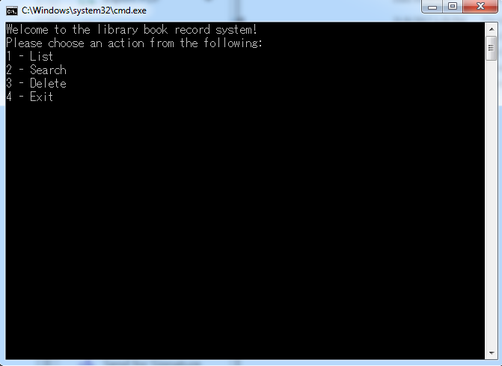

Sample Output #2:

List Function:

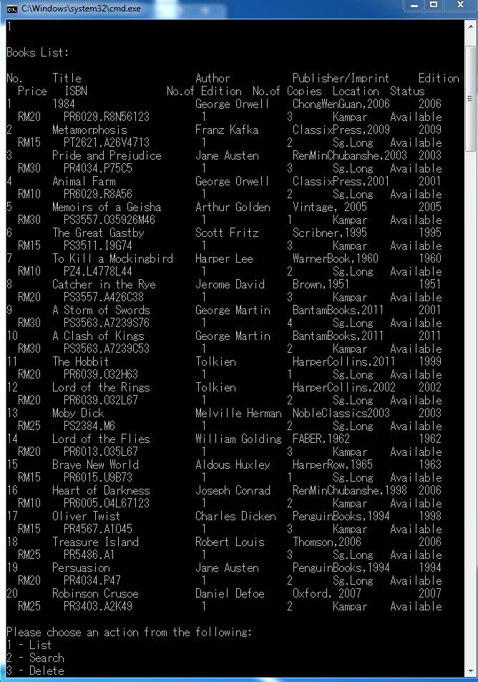

Sample Output #3:

Search function: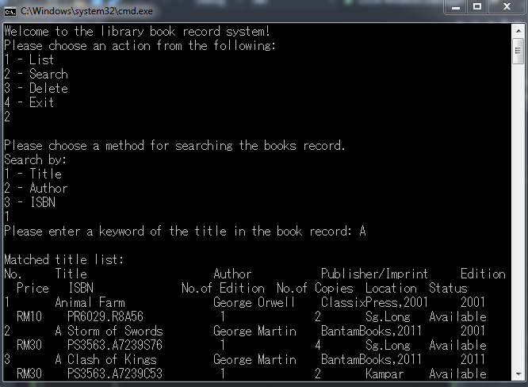

Sample Output #4:

Delete Function: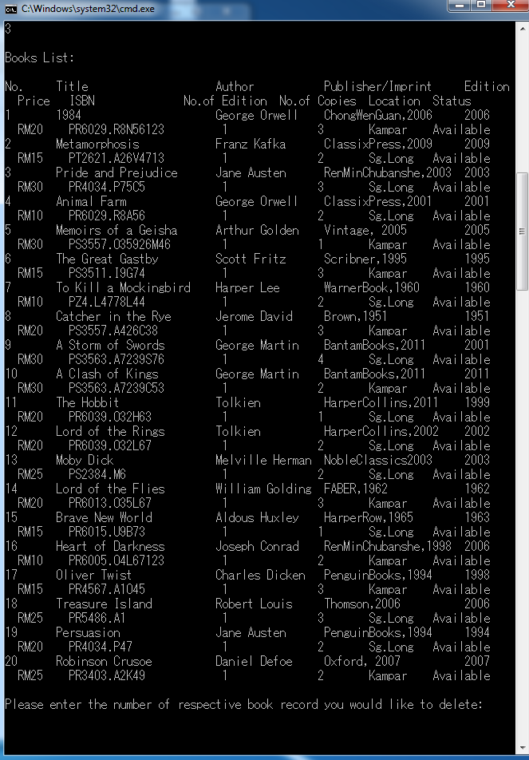

Sample Output #5:

Exit Function:

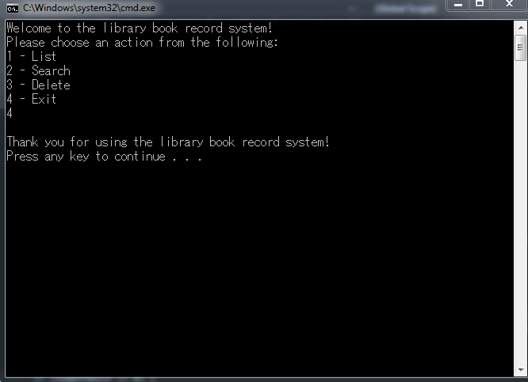

**INPUT DATA SAMPLE:**

**Test Case 1 - Search by Author:**

For example, ‘George’ is typed, and a list of Author with the name ‘George’ appeared.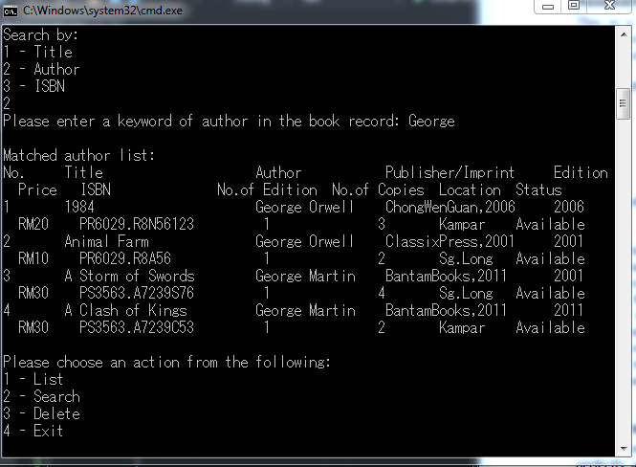

**Test Case 2 - Search by Title:**

For example, ‘Pride’ is typed in, and the list of books with the keyword appeared.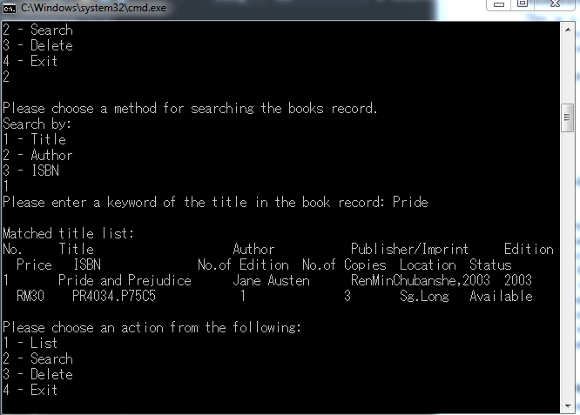

**Test Case 3 -Search by ISBN:**

As shown below, when ‘PS’ is typed in, a list of books with the ISBN of ‘PS’ appeared.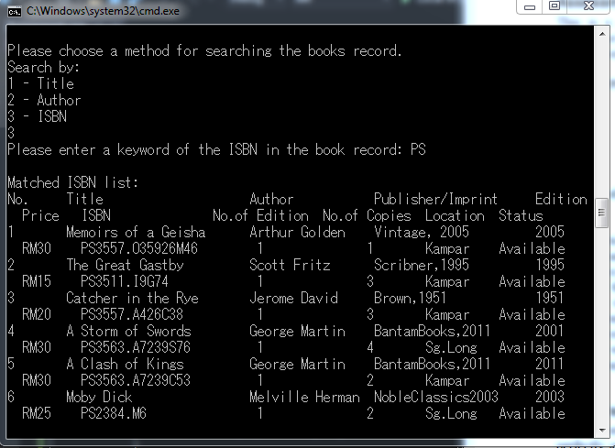

**Test Case 4 - Deletion of Booklist:**

As an example, ‘Robinson Crusoe’ is in the 20th book record, and it’s been chosen to be deleted.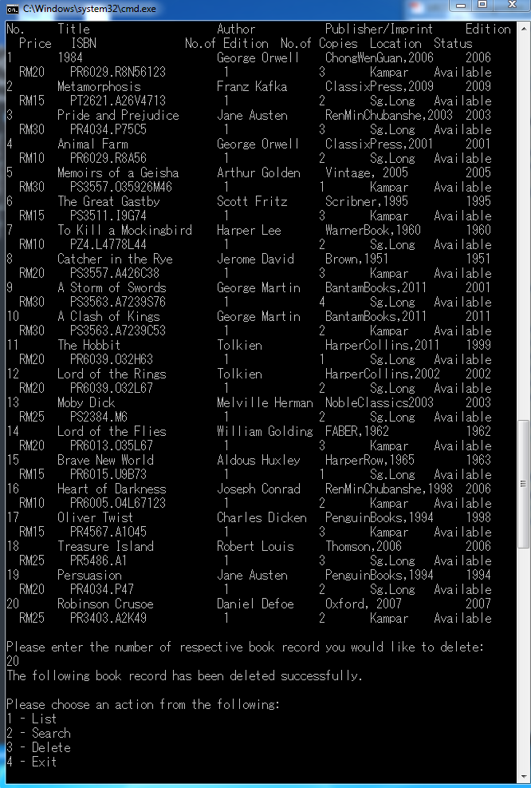

When list function is used again, there are now 19 books instead of 20 as ‘Robinson Crusoe’ has been deleted.

